Chapter 4, Problem 53.

Find the Norton equivalent at terminals a-b of the circuit in Fig. 4.119.

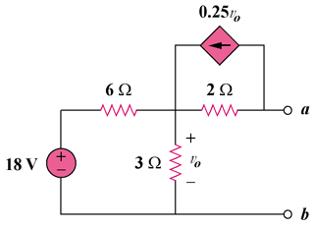

Figure 4.119
For Prob. 4.53.

